

Faculty of Engineering and Technology
Department of Electrical & Computer Engineering
OPERATING SYSTEM
ENCS3390
Programming Task 2:
Banker’s Algorithm

Student #1: Rawan Fares No. :1231043
Student #2: Rama Alrob No. :1231564

Supervised by: Dr. Yazan Abu Farha , Dr. Ismail Khater.

June 2026

Table of Contents
Table of Tables 2

Table of Tables
Table ‎0.1:Problem Instance. 5
Table ‎0.2:Algorithm Parameters. 6
Table ‎0.1:Full Results Table. 7
Table ‎0.1:Effect of λ on Both Algorithms. 8
Table ‎0.1:population points and selected hospital locations. 9

1. A valid request that is granted
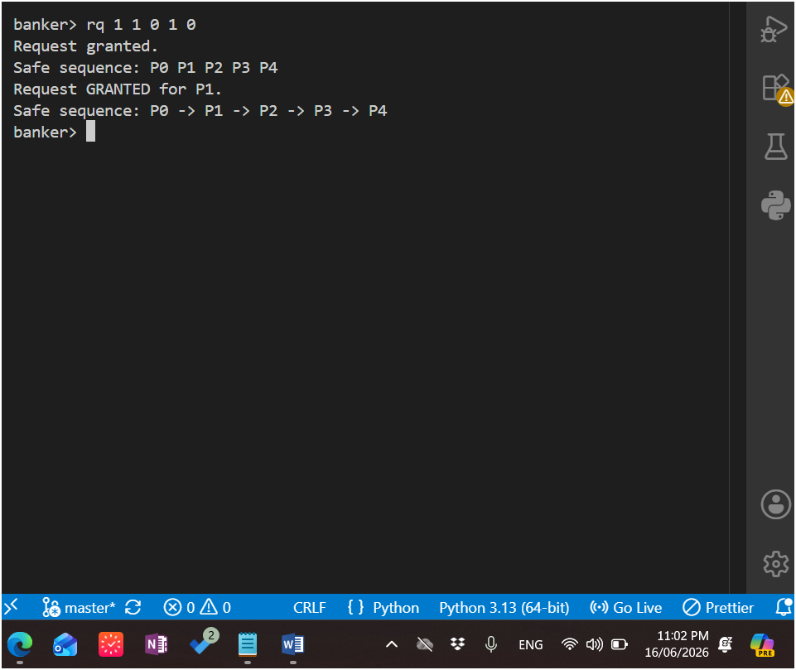

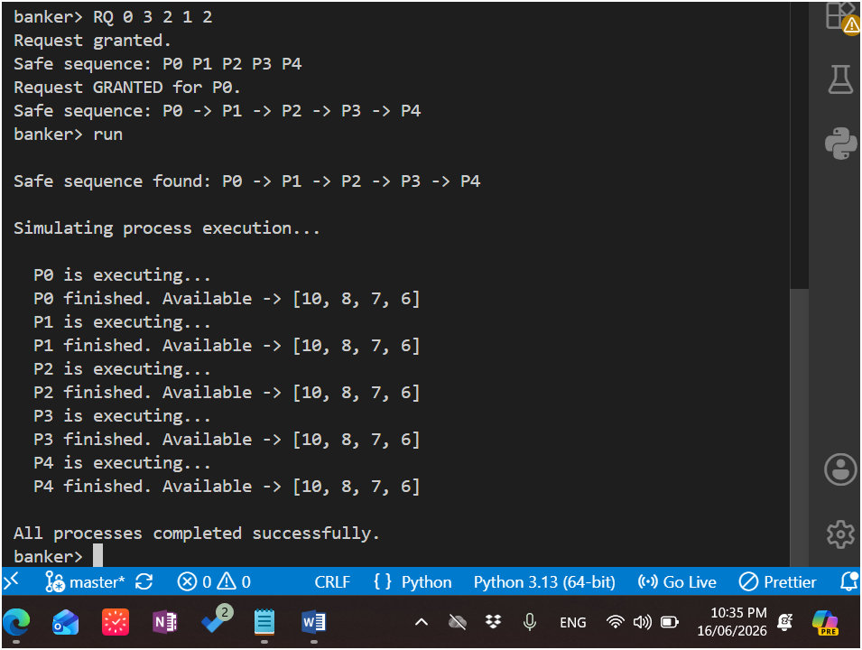

2. A request denied due to unsafe state
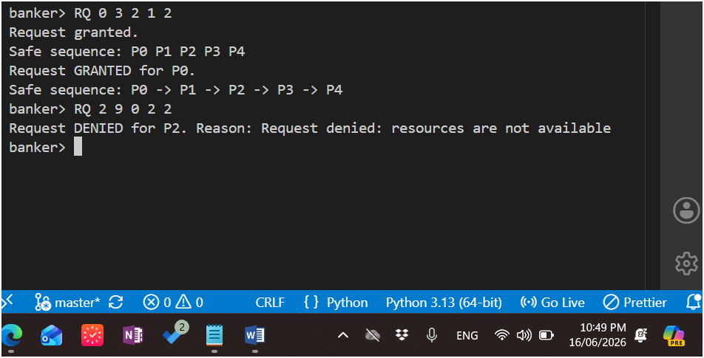
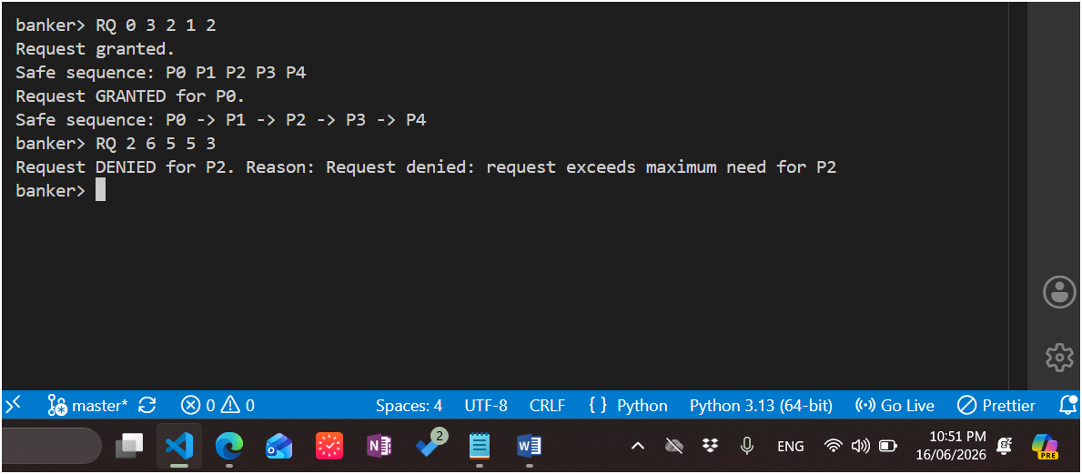

3- A valid request that is granted
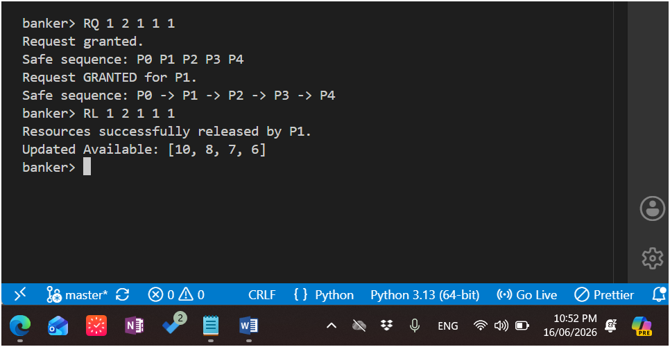

Test 4 — Invalid resource release
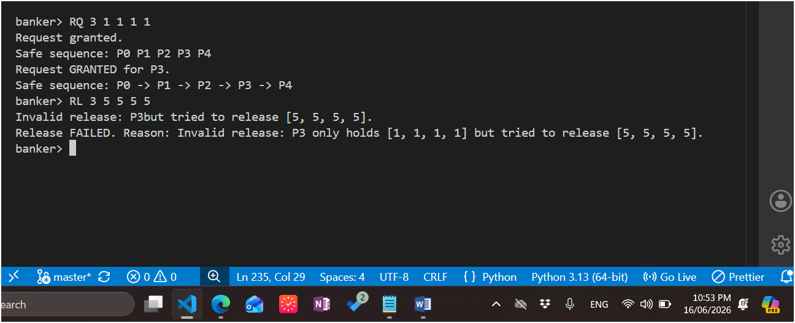

Test 5 — Multiple sequential requests and releases
RQ 0 2 1 1 1
RQ 1 1 1 1 1
RQ 3 1 1 1 1
*
RL 1 1 1 1 1
RQ 4 2 2 2 2
*

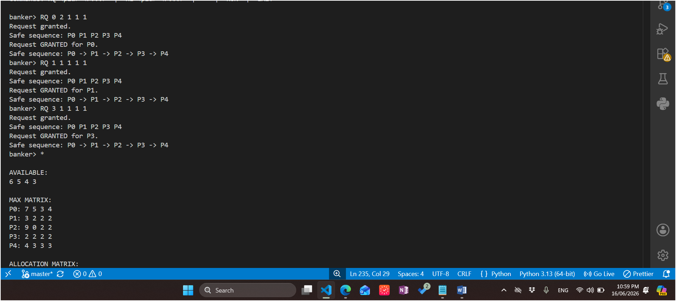
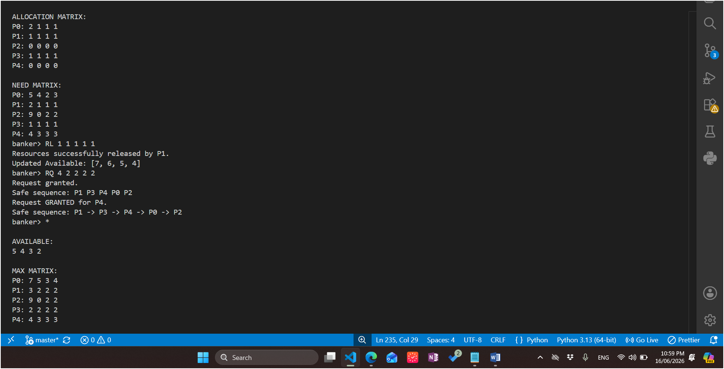

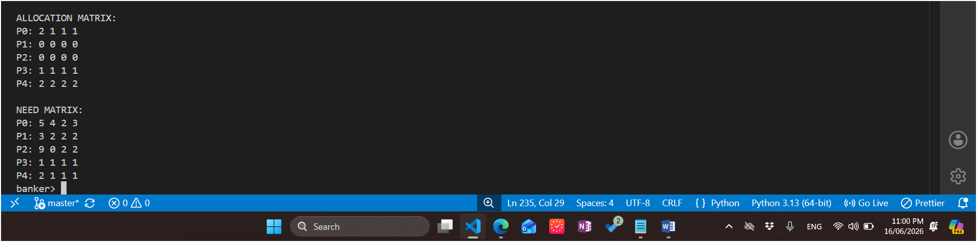

banker> RQ 0 2 1 1 1
Request granted.
Safe sequence: P0 P1 P2 P3 P4
Request GRANTED for P0.
Safe sequence: P0 -> P1 -> P2 -> P3 -> P4
banker> RQ 1 1 1 1 1
Request granted.
Safe sequence: P0 P1 P2 P3 P4
Request GRANTED for P1.
Safe sequence: P0 -> P1 -> P2 -> P3 -> P4
banker> RQ 3 1 1 1 1
Request granted.
Safe sequence: P0 P1 P2 P3 P4
Request GRANTED for P3.
Safe sequence: P0 -> P1 -> P2 -> P3 -> P4
banker> *

AVAILABLE:
6 5 4 3

MAX MATRIX:
P0: 7 5 3 4
P1: 3 2 2 2
P2: 9 0 2 2
P3: 2 2 2 2
P4: 4 3 3 3

ALLOCATION MATRIX:
P0: 2 1 1 1
P1: 1 1 1 1
P2: 0 0 0 0
P3: 1 1 1 1
P4: 0 0 0 0

NEED MATRIX:
P0: 5 4 2 3
P1: 2 1 1 1
P2: 9 0 2 2
P3: 1 1 1 1
P4: 4 3 3 3
banker> RL 1 1 1 1 1
Resources successfully released by P1.
Updated Available: [7, 6, 5, 4]
banker> RQ 4 2 2 2 2
Request granted.
Safe sequence: P1 P3 P4 P0 P2
Request GRANTED for P4.
Safe sequence: P1 -> P3 -> P4 -> P0 -> P2
banker> *

AVAILABLE:
5 4 3 2

MAX MATRIX:
P0: 7 5 3 4
P1: 3 2 2 2
P2: 9 0 2 2
P3: 2 2 2 2
P4: 4 3 3 3

ALLOCATION MATRIX:
P0: 2 1 1 1
P1: 0 0 0 0
P2: 0 0 0 0
P3: 1 1 1 1
P4: 2 2 2 2

NEED MATRIX:
P0: 5 4 2 3
P1: 3 2 2 2
P2: 9 0 2 2
P3: 1 1 1 1
P4: 2 1 1 1
banker>

